American University of Beirut
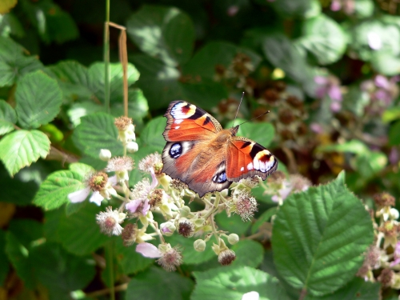
Faculty of Arts & Sciences
Department of Biology
Summer -2011

Biology 202: General Biology II
http://www.freedigitalphotos.net/details.php?gid=63&sgid=&pid=221

Course instructor:
Dr. Sawsan Kreydiyyeh
Biology bldg, Room 305
Email: sawkreyd@aub.edu.lb

Dates to Remember
June 20, 2011 – June 22, 2011: Change of Schedule (Drop and Add)
July 22nd , 2011: Last Day for WITHDRAWAL from Courses
August 5, 2011: Last day of classes
August 8, 2011 – August 13, 2011: Examination period

Exams Schedule

First Lecture Exam: Tuesday July 5, 2011
Second Lecture Exam: Thursday July 21, 2011
Final Exam: TBS

Course description:
The course gives an overview of plant's and animal's systems and emphasizes the correlation between structure function as well as the evolutionary relationships between different groups of organisms. Students will learn how multicellular organisms are organized, what the functions of the different tissues and systems are and how are their activities coordinated to maintain homeostasis. The lab component reinforces the biological concepts and principles and provides hands on experience in research and data interpretation.

Student learning outcomes  By the end of the course you should be able to | Assessment tool
Use biological terms in the proper context | Glossary , exams, lab reports, preparation of exam questions
Explain mechanisms underlying plant and animal functions | Exams, discussion forums, class discussions, preparation of exam questions
Analyze the functional relationship between different organs and systems in an organism | Exams, discussion forums, class discussions, preparation of exam questions
Relate the complexity of form and function to the evolution of organisms | Exams, discussion forums, class discussions
Interpret experimental data | lab report, lab quizzes
Demonstrate skills in basic laboratory techniques | lab practicum
Demonstrate basic skills in using databases to retrieve biological information | Research assignment

Textbook: Biology by Raven and Johnson, 9th edition, McGraw Hill, 2011
Laboratory Manual: Biology Laboratory Manual, Vodopich & Moore, 9th Ed, 2011.

Course policies

Attendance and class etiquette
Satisfactory performance in this course requires regular attendance. Class attendance is highly recommended. Absence of a student does not exempt him/her from the responsibility of the work done or from any announcement made during the missed session. Students who miss classes excessively will be asked to drop from the course (AUB catalogue p 128).You are expected to be in class on time. Late comers will not be admitted.
Disruptive behavior in the class will not be tolerated. Excessive talking, use of cell phones are all examples of disruptive behavior.
Students who choose to disrupt the class will be asked to leave.

Participation in the class is expected of all students. Although this is a large class, you will be given many opportunities to contribute.
There is also an online component to your participation. Students who lack internet access from home can access the course from any of the computer labs available on campus.

Study Policies:
Students are encouraged to ask questions in lecture and lab sessions to clarify the information being presented. Because of class size, questions are best handled in moodle forums where all the class may participate in answering your questions. The instructor will monitor the answers given and either approves them or correct them if they are wrong.
There are many new technical terms and concepts to be mastered during this course. Pay careful attention to word spellings and definitions. A glossary will be opened on moodle where students will be asked to enter at the end of each chapter, the term whose definition is given. Scientific terms should be spelled properly in exams, lab assignments and lab reports.

The textbook is your source of detailed information and supplements the lecture material.

Assessment and Grading
This course is a prerequisite to all other biology courses.

Percentage of final grade date
Lab 25

Lecture
Quiz I 20 Tuesday July 5, 2011
Quiz II 20 Thursday July 21, 2011
Final Exam 32
glossary 03

Outline

 | topic | chapter
Week 1 | Overview of green plants | 30
Week 2 | Plant form | 36
 | Vegetative plant development | 37
Week 3 | Transport in plants | 38
Week 4 | Plant nutrition and soil | 39
Week 4 | Sensory systems in plants | 41
Week 5 | Sensory systems in plants | 41
Week 5 | Plant reproduction | 42
Week 5 | The animal body and principles of regulation | 43
Week 6 | Nervous system | 44
Week 7 | Nervous system | 44
Week 7 | Sensory system | 45
Week 8 | Sensory system | 45
Week 9 | Musculoskeletal system | 47
Week 10 | Digestive system | 48
Week 11 | Respiratory system | 49
Week 12 | Circulatory system | 50
Week 13 | Osmotic regulation and urinary system | 51
Week 14 | The endocrine system | 46

